**SAFETY COMMUNIQUE**

**Throwing Safety – Training and Competition**

All of the implements that are thrown at athletics training sessions and during competitions have the potential to be lethal weapons if their use is not properly managed and supervised at all times.

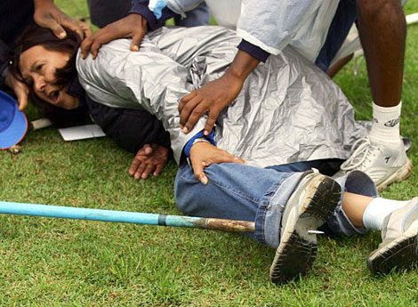A concerning number of near misses in recent months has led UKA to release this safety communique to all athletes, coaches, officials and facility operators as a means of reinforcing existing safety protocols and increasing the awareness of the dangers of throwing events. Throwing events, be it during training or competition, should always be properly managed and supervised. *Note: the most serious of these recent near misses involved a young athlete walking on the infield (to retrieve an implement), being struck a glancing blow on the neck by the wire of a hammer in full flight… The athlete concerned was extremely fortunate to leave the infield with minor neck injuries in an incident that had the potential to be significantly worse - even fatal.*

Near misses are an indication that something is wrong and some corrective action is needed. Good safety management tells us that as the number of near misses increases the chances of a major incident increases. This is the position we find ourselves in today, and I am sure all of you will agree that none of us would ever want to have to deal with the aftermath of a major accident or fatality in our sport.

**Safety MUST ALWAYS come first** ….. Impact or contact from an “in-flight” hammer, discus, javelin or shot will almost certainly result in a serious or fatal injury. It is the responsibility of all officials coaches and athletes to ensure that all competition and training sessions are conducted in a safe manner and it is imperative that the guidance contained in the UK Athletics Code of Practice (pages 25-31) is followed at all times. Click [here](http://www.britishathletics.org.uk/EasysiteWeb/getresource.axd?AssetID=133673&type=full&servicetype=Attachment) to download.

**Top Five Throwing Safety Essentials**

1. **NEVER, EVER** turn your back on a throws circle or runway!
2. **NEVER** forget rule #1
3. Always adhere to the [UKA Safe Code of Practice](http://www.britishathletics.org.uk/EasysiteWeb/getresource.axd?AssetID=133673&type=full&servicetype=Attachment)
4. Keep your eyes on the throws circle at all times, even when it is separated by a cage.
5. Check that all cages are compliant with the UKA rulebook and are regularly inspected and maintained

For those who coach and officiate during throwing sessions/events it is essential to remain vigilant at all times as bystanders, spectators and even athletes are not always as aware of the dangers associated with throwing events and it your responsibility to inform and educate them - sometimes firmly - for their own good and for your peace of mind.

The key message in all of this is that safety must be the concern and responsibility of everyone involved in throwing activities – facility operators, coaches, officials, meeting organisers, meeting managers, event staff, athletes and spectators. It is important that we all put safety first and make it our goal to eliminate the concerning number of near misses and incidents that we are currently experiencing in the sport.